7. Write a program for Pre-processing of a Text Document: stop word removal

Input

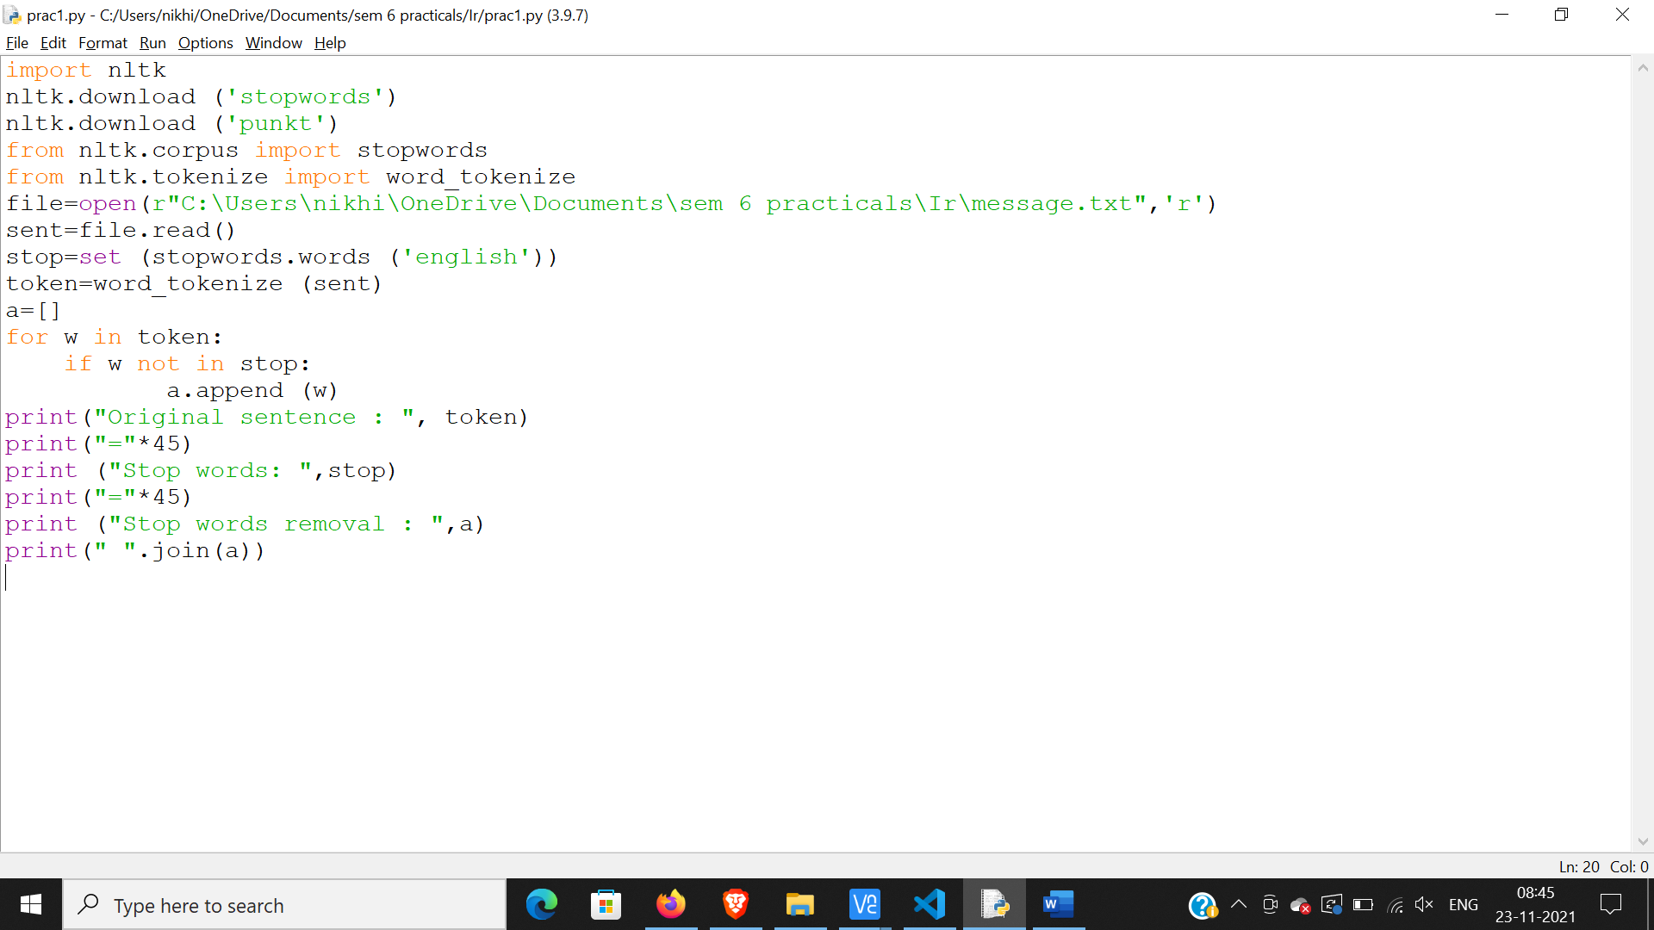

Output:

